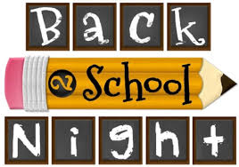

BARNEGAT HIGH SCHOOL
180 Bengal Blvd.
Barnegat, NJ 08005
Monday, September 21st, 2020
Beginning at 6:45 p.m. Via Virtual Classroom
- Meet your child’s teachers as you follow their daily schedule via virtual classroom

- Spend an evening learning about course objectives, content, requirements, teaching methods and materials as well as evaluation techniques.

- Back to School Night is an informative night. If you would like to discuss your child in depth with a teacher, please do not hesitate to make an appointment with your child’s teacher.

- Special Instructions:
  - Links to join virtual classrooms will be posted on the BHS webpage by September 18th. Please select the teacher’s like to join their classroom at the appropriate time.
  - Please sign in to first period by 6:55p.m. Student schedules will be distributed in school and are available on Parent Portal.

